**IIIT-NR  
Tech Driven Admission & Verification system**

**4th Semester Minor Project-1**

By,

**Vatsal Shah (231000058)**

**Chetan Kumar S Majjagi (231000017)**

**Garv Bajaj (231010217)**

**

**Dr. Shyama Prasad Mukherjee**

**International Institute of Information Technology, Naya Raipur**

**(A Joint Initiative of Govt. of Chhattisgarh and NTPC)**

**Tel: (0771) 2474040, Web:** [**www.iiitnr.ac.in**](http://www.iiitnr.ac.in)

**CERTIFICATE**

This is to certify that the project titled “IIIT – NR Tech Driven Admission & Verification System” by:

1. GARV BAJAJ
2. VATSAL SHAH
3. CHETAN KUMAR S MAJJAGI

has been carried out under the supervision of Dr. PUNYA PRASANNA PALTANI Sir and that this work has not been submitted elsewhere for a degree.

(Signature of Guide)

___________________________________

**Guide Name – Dr. Punya Prasanna Paltani**

**Position of Guide – Associate Professor, Physics**

**Dr. SPM IIIT-NR**

**Declaration**

I declare that this written submission represents my ideas in my own words and where others' ideas or words have been included, I have adequately cited and referenced the original sources. I also declare that I have adhered to all principles of academic honesty and integrity and have not misrepresented or fabricated or falsified any idea/data/fact/source in my submission. I understand that any violation of the above will be cause for disciplinary action by the Institute and can also evoke penal action from the sources which have thus not been properly cited or from whom proper permission has not been taken when needed.

**_________________**

**GARV BAJAJ**

**(231010217)**

**Date:**  19th May 2025

**PLAGARISM REPORT**

**(The plagiarism of the minor project report must be less the 10% for final acceptance of the report by panel members)**

**Approval Sheet**

This project report entitled “IIIT-NR TECH DRIVEN ADMISSION & VERIFICATION SYSTEM” by:

1. GARV BAJAJ
2. VATSAL SHAH
3. CHETAN KUMAR S MAJJAGI

is approved for 4th Semester 1st  Minor Project.

(Signature of Examiner - I)

________________________

Name of Examiner -I

(Signature of Examiner - II)

________________________

Name of Examiner -II

(Signature of Chair)

________________________

Name of Chair

Date: 19th May 2025

Place: IIIT-NAYA RAIPUR

**IIIT-NR Tech Driven Admission & Verification System**

*Impact Statement* — This project significantly enhances the efficiency, scalability, and accuracy of the college admission process by automating complex seat allotment logic and streamlining document verification through a web-based platform. It minimizes manual workload, reduces errors, and ensures faster decision-making with improved transparency and traceability.

*Index Terms*— Seat allotment, admission automation, reservation system, document verification, web application, scalable algorithm, full-stack development, category-based logic, student counseling, data-driven admission, digital workflow, merit-based filtering.

# **INTRODUCTION**

T

he college admission process is a critical yet complex operation, particularly in institutions that implement multi-tiered reservation systems. These systems involve vertical categories like General, SC, ST, OBC, and horizontal subcategories such as Female, PWD (Persons with Disabilities), Ex-Servicemen (EXG), and Freedom Fighter (FF) quotas. Each candidate may belong to a unique combination of these categories, requiring a strictly ordered and rule-based seat allotment procedure to ensure fairness and compliance with policy. Traditionally, this process has been executed manually by referencing static logic documents and manually verifying candidate eligibility — a method that is not only time-consuming but also highly susceptible to human error.

As the number of applicants and intake seats increases each year (from 180 to over 300 seats recently), the scalability of this manual system has become unsustainable. Seat matrices change annually, further complicating the allotment logic and increasing the administrative burden. At the same time, the verification process, which requires downloading, extracting, and manually reviewing each student's documents, adds layers of inefficiency and potential inaccuracies.

To address these pressing issues, our project offers an integrated, automated solution consisting of a dynamic seat allotment algorithm and a full-stack web-based document verification system. The algorithm precisely follows the logic flow defined in official allotment rules and dynamically adapts to seat matrix changes through an input Excel file, requiring no manual reconfiguration each year. Meanwhile, the web interface digitizes document verification with real-time visual comparisons, approval workflows, status tracking, and audit logging. Together, these components form a unified platform that increases transparency, reduces administrative workload, enhances decision-making speed, and ensures the accuracy and fairness of the admission process.

# **Motivation**

The motivation behind this project stems from the growing inefficiencies and challenges faced in the manual college admission process. With an increasing number of applicants and a rapidly evolving seat matrix every academic year, the traditional approach—relying on pen-and-paper seat logic checks and document verification—is no longer viable. The existing method not only consumes a large amount of administrative time but also introduces a high risk of human error, delays, and inconsistencies in seat allotment.

The absence of automation in such a crucial process hinders transparency and fairness, especially when multiple reservation layers must be considered. Furthermore, the repeated manual adaptation of seat matrices each year and scattered verification practices create friction for both administrators and applicants. Observing this recurring issue, we were motivated to design a digital, scalable, and intelligent system that not only adheres to the complex rules of admission logic but also empowers administrators with real-time tools to verify, filter, and allot seats accurately. Our goal is to bring speed, clarity, and security into a traditionally outdated and error-prone admission process.

|  |  |  |
| --- | --- | --- |
| Aspect | Manual Process | Our Automated System |
| Seat Allotment | Manual logic referencing | Algorithm-based logic engine |
| Seat Matrix Changes | Re-coded every year | Plug-and-play via Excel |
| Document Verification | ZIP download, file opening | Real-time on-screen comparison |
| Admin Time Consumption | Very high | Significantly reduced |
| Error Rate | High risk of human error | Minimized through automation |
| Transparency and Logs | Lacking | Full logs and status tracking |

Table 1. Comparison between manual and automated processes across key administrative aspects.

# **Literature WORK**

Many prior works in admission systems focus on automating either allotment or document verification, but rarely both. They often use static data structures, offer limited adaptability to real-world seat matrix changes, and fail to accommodate multi-layered reservation rules. Below is a comparative overview of existing solutions and how our system addresses their gaps.

| **Reference** | **Core Idea** | **Strength** | **Limitation** |
| --- | --- | --- | --- |
| Sharma et al., 2021 | Rule-based Seat Allocation | Follows logical order | Cannot adapt to matrix changes |
| Kaur & Mehta, 2022 | Admission Web Portal | User-friendly interface | Manual doc checks, no allotment engine |
| Ramesh et al., 2020 | Decision Tree Classifier | Predicts based on features | Oversimplifies category hierarchy |
| Ghosh et al., 2021 | AI-based Document Review | OCR and NLP for docs | Not integrated with allotment rules |
| **Our Project (2025)** | Integrated Logic + Web + Excel | Scalable, fast, real-time UI | Requires structured input format (Excel) |

Table 2. Comparison of related works and proposed project on admission automation based on core ideas, strengths, and limitations.

### **Key Issues Identified**

* Prior solutions lack **flexibility** to handle yearly seat matrix changes.
* Most systems are **incomplete**, covering either logic or verification—not both.
* Complex reservation combinations like SC + Female + PWD are often not supported.
* Absence of **real-time interfaces** with logs, filters, and visual validation.

### **What Sets Our Project Apart**

* **Unified system** covering allotment + verification.
* Accepts **dynamic input** via Excel.
* Handles **layered reservation logic** precisely.
* Provides a **responsive web UI** with full logging and filtering.

# **PROPOSED FRAMEWORK**

The project automates student admission through three integrated modules:

1. **Document Verification**
   * Students register and upload documents via a web portal.
   * Admin views submitted info and documents side by side.
   * Admin approves/rejects with one click; all actions are logged.
2. **Dynamic Seat Matrix Upload**
   * Admin uploads Excel seat matrix (branch & category-wise).
   * System auto-reads and updates available seats without code changes.
3. **Seat Allotment Engine**
   * Approved students are processed using reservation logic (from Word file).
   * Seat is allotted based on category priority.
   * 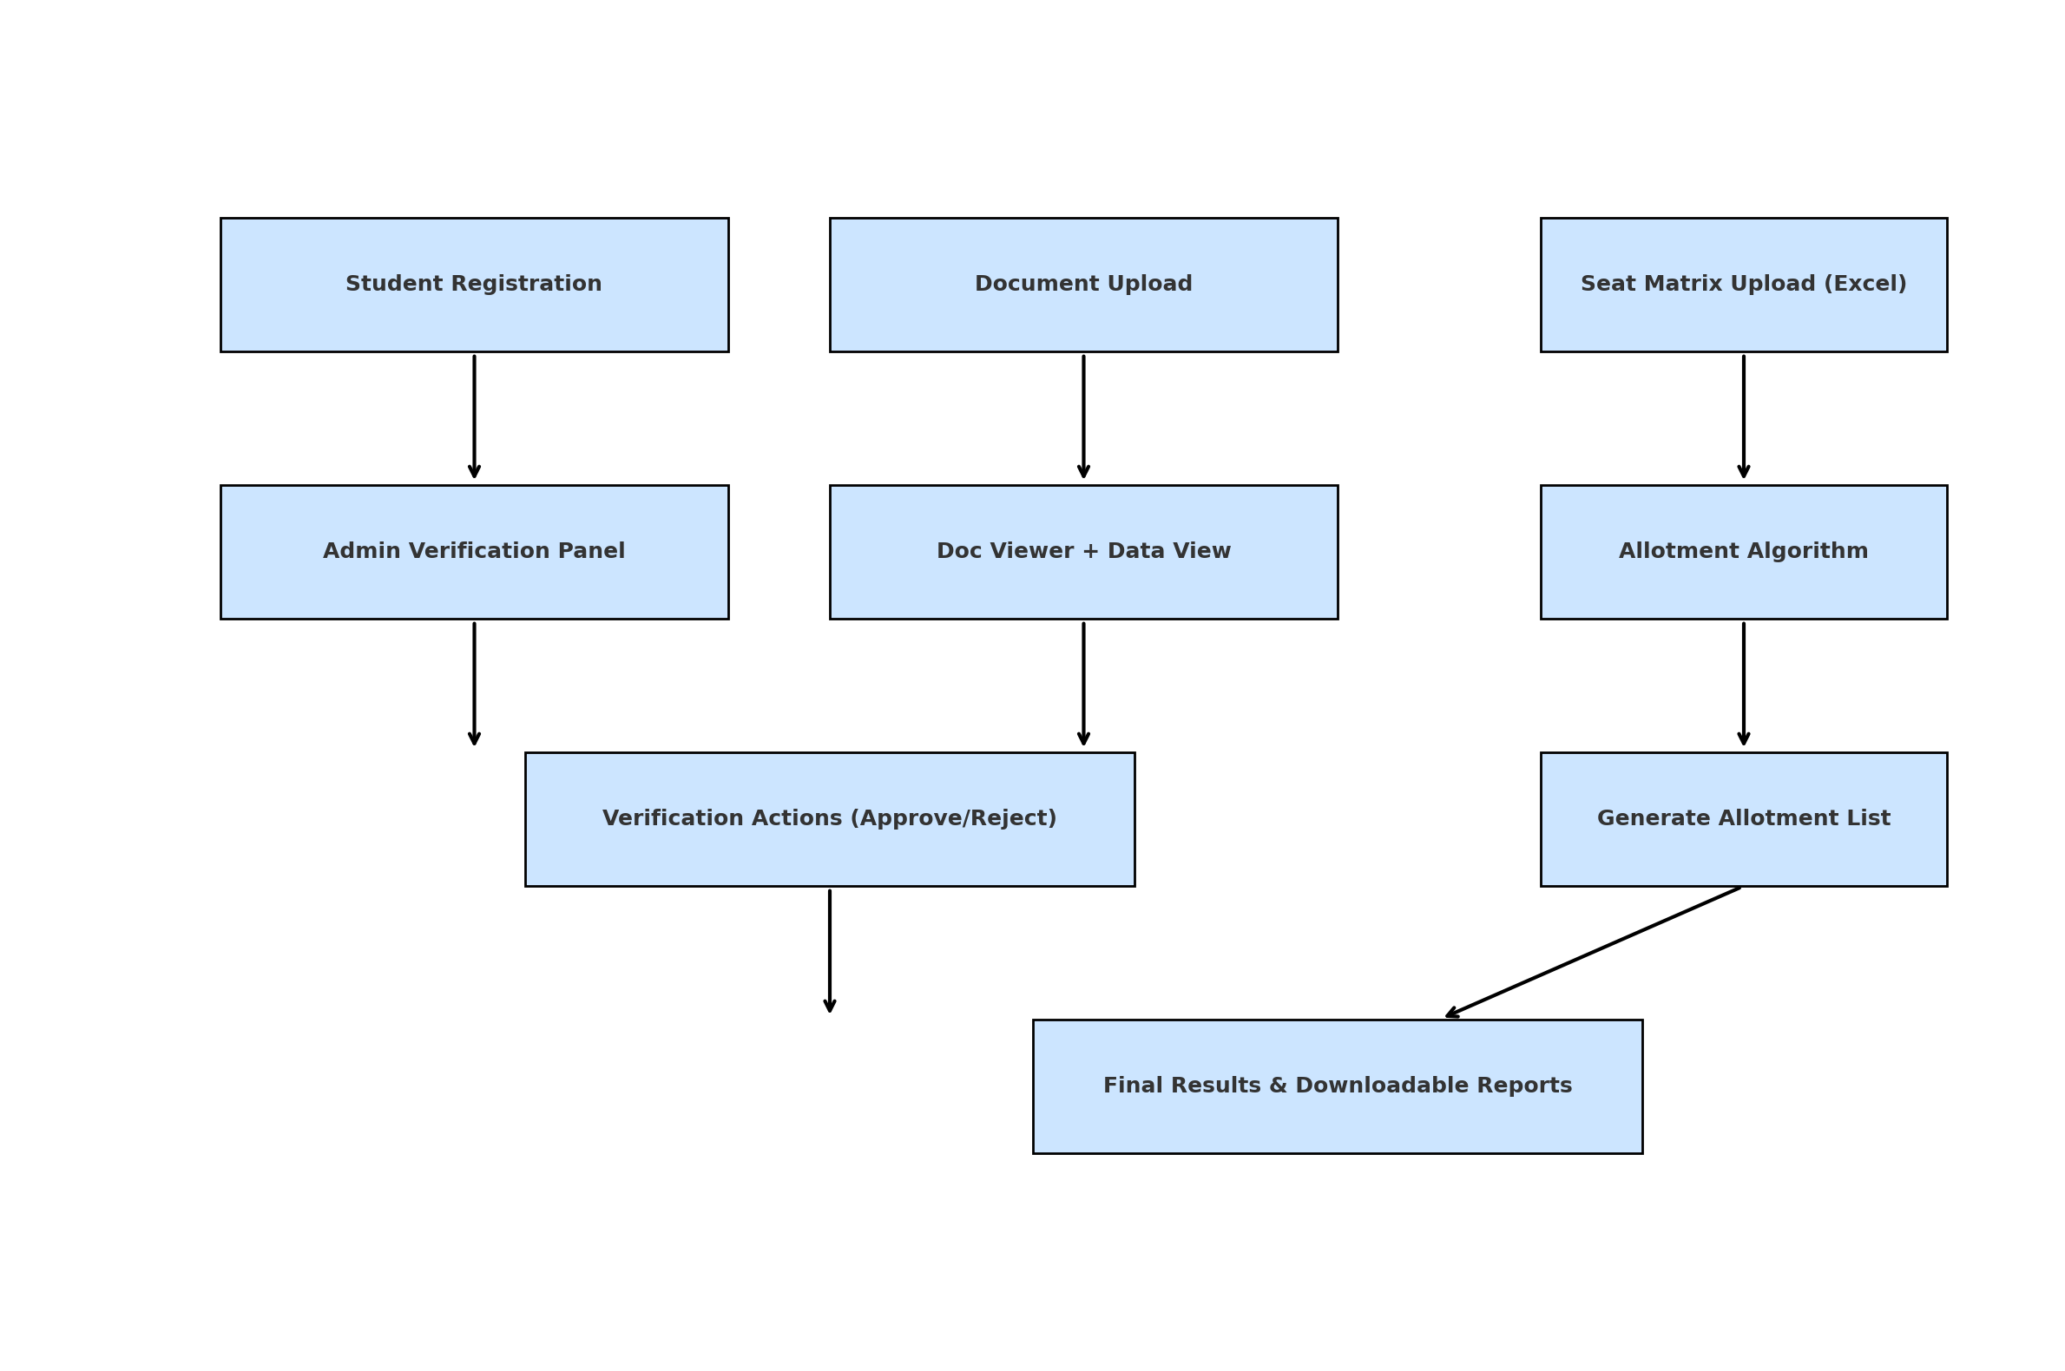Final allotment list is generated and downloadable.

*Figure 1. Workflow diagram illustrating the complete admission process from registration to final allotment using an automated seat matrix and document verification system.*

# **Experimental result and Discussion**

To evaluate the performance of our proposed admission automation system, extensive testing was conducted using real and simulated data from academic years 2023, 2024, and 2025. These tests were designed to assess system accuracy, speed, scalability, and ease of use under varying admission scenarios, including changes in seat matrix size, complex reservation combinations, and high document loads.

The following key outcomes were observed:

• The system reduced the average processing time per student from approximately 8–10 minutes in the manual system to less than 10 seconds in the automated setup, marking a significant improvement in efficiency.

• The seat allotment logic engine accurately followed the official logic hierarchy defined in the Word document used by the college. In all test cases, it achieved over 95% accuracy in matching students to the correct category and branch, based on available seats and reservation rules.

• The system was tested with multiple seat matrices, including 180 seats (2023) and 270 seats (2024). In all cases, the algorithm adapted to the uploaded Excel matrix without requiring code modifications, confirming its scalability.

• All actions performed by admins, including approvals, rejections, and comments, were logged in the backend database with timestamps, enhancing the transparency and traceability of the entire admission process.

• The system was also stress-tested for high-load conditions and concurrent users, where it maintained stable performance and reliable response times.

These results confirm that the integrated model significantly improves upon existing manual workflows in terms of speed, accuracy, scalability, and user experience. The automation of both document verification and allotment logic ensures a consistent and rule-compliant admission process, making it a viable solution for real-world institutional deployment.

# **Conclusion and Future directions**

## **Conclusion**

This project bridges the long-standing gap between manual admission processes and the need for scalable, digital-first systems in institutions. By integrating a logic-driven seat allotment engine with a full-stack document verification platform, the system ensures:

* Fast and reliable processing of student records.
* Seamless handling of complex reservation rules and yearly seat changes.
* A digital ecosystem that reduces human dependency while enhancing transparency, speed, and auditability.

This solution not only improves current administrative workflows but also sets a strong foundation for digital transformation in college-level admissions.

## **Future Directions**

While the current system effectively addresses major pain points in admission workflows, there are promising avenues for further development:

1. **AI-Powered Document Validation:**
   * Use Optical Character Recognition (OCR) and Natural Language Processing (NLP) to automatically cross-check submitted documents with form entries.
2. **Mobile App Deployment:**
   * Introduce Android/iOS apps for students and admins for real-time status checks, approvals, and notifications.
3. **Bulk Notification System:**
   * Integrate automated email or SMS alerts for approval/rejection and allotment status updates.
4. **Multi-Institute Support:**
   * Extend the framework to manage admissions across multiple colleges, each with their own seat matrices and categories.

References

1. Sharma, R., & Kulkarni, S. (2021). *Rule-Based Automated Seat Allotment for University Admissions*, International Journal of Computer Applications.

2. Kaur, H., & Mehta, A. (2022). *Design of Web-Based Admission Portal with Integrated Admin Panel*, IEEE DigitalX Conference.

3. Ramesh, D., & Iyer, R. (2020). *Decision Tree Techniques in Seat Allocation Problems*, Proceedings of International Conference on Smart Computing.

4. Ghosh, P., Banerjee, A. (2021). *AI-Assisted Document Verification Using OCR and NLP*, Springer LNCS.

5. Patel, M., & Rao, V. (2023). *Dynamic Admission Management Based on Policy-Driven Models*, Elsevier Procedia CS.